WESTSIDE PROJECT

boyBand.html

<section class="row-fluid">

<div id="wrapper">

<!-- Sidebar -->

<div id="sidebar-wrapper">

<ul class="sidebar-nav">

<li class="sidebar-brand">

<button class="btn btn-info btn-primary">

<i class="icon ion-music-note"></i>

Songs

</button>

</li>

<ul class="sidebar-brand">

<!-- <button ng-repeat='song in songList' class="btn btn-small btn-primary" -->

<button ng-repeat='song in boySongList' class="btn btn-small btn-primary"

ng-click='getSingerName(song)'

>

<i class="icon ion-headphone"></i>

{{song.TITLE}}

</button>

</ul>

</ul>

</div>

<!-- /#sidebar-wrapper -->

<!-- Page Content -->

<div id="page-content-wrapper">

<h3>

<i class="icon ion-person-stalker"></i>

{{selectedSong.TITLE}}

</h3>

<li>

{{selectedSinger}}

</li>

<div class="container-fluid">

<div class="row">

<div class="col-lg-6">

<h4 ng-repeat='video in selectedVideoList'>

<!-- <h4> -->

<div class="row">

<div class="col-lg-3">

<img ng-src="img/{{video.SINGERNAME}}.png" >

</div>

<a href="" ng-click='getVideo4singer(video)' >

{{video.SINGERNAME}}

</a>

</div>

</h4>

</div>

<video controls="controls" name="Video Name" ng-src="{{getVideoUrl()}}"></video>

</div>

</div>

</div>

<!-- /#page-content-wrapper -->

</div>

</section>

******************************END boyBand.html

**Controllers.js**

'use strict';

/* Controllers */

angular.module('myApp.controllers', [])

.controller('boyCtrl', function($scope,$http,$routeParams,$sce,getSingerService) {

// $scope.selectedCat={};

$scope.selectedSinger="";

$scope.selectedSong={};

$scope.girlSongList=[{}];

$scope.boySongList=[{}];

$scope.selectedVideoList=getSingerService.clear();

//*****get json data************************************

// $http.get('js/applicants.json').success(function(data){

$http.get('js/singers.json').success(function(data){

// $scope.projcatList=data.applicants;

$scope.singerList=data.singers;

// $scope.selectedCat=$scope.applicantList[0];

});

$http.get('js/songs.json').success(function(data){

$scope.songList=data.songs;

//***********list girl songs**********************

getSingerService.clearGirlSong();

angular.forEach($scope.songList,function(s){

if(s.DELETED=="Yes"){

$scope.girlSongList=getSingerService.saveGirlSong(s);

}

});

$scope.girlSongList=getSingerService.listGirlSong();

//****************list boy songs**************************

getSingerService.clearBoySong();

angular.forEach($scope.songList,function(s){

if(s.DELETED!="Yes"){

$scope.boySongList=getSingerService.saveBoySong(s);

}

});

$scope.boySongList=getSingerService.listBoySong();

});

//**********get json data

$http.get('js/videos.json').success(function(data){

$scope.videoList=data.videos;

// $scope.selectedVideoList=getSingerService.clear();

});

//***************************************

$scope.getSingerName=function(song){

// $scope.test="*************";

if (song.ID!=""){

getSingerService.clear();

};

angular.forEach($scope.videoList,function(s){

if(s.SONGID==song.ID){

getSingerService.save(s);

}

});

$scope.selectedVideoList=getSingerService.list();

$scope.selectedSong=song;

};

//************************************

***$scope.getVideo4singer=function(video){***

***$scope.video4singer=video.CONTACTNAME;***

***$scope.selectedSinger=video.SINGERNAME;***

***};***

**//***********$scope.video4singer is not passed a OBJECT, but a property, that is the problem. OBJECT represent a RECORD IN DATABASE. \*\*\*\*\*\*\*\*\*\*\*\*\*\*\*\*\*\***

$scope.getVideoUrl=function(){

return $sce.trustAsResourceUrl("media/"+$scope.video4singer+".mp4");

};

});

***********************************End Controllers.js

WRONG ! CAUSE THE FOLLOWING:

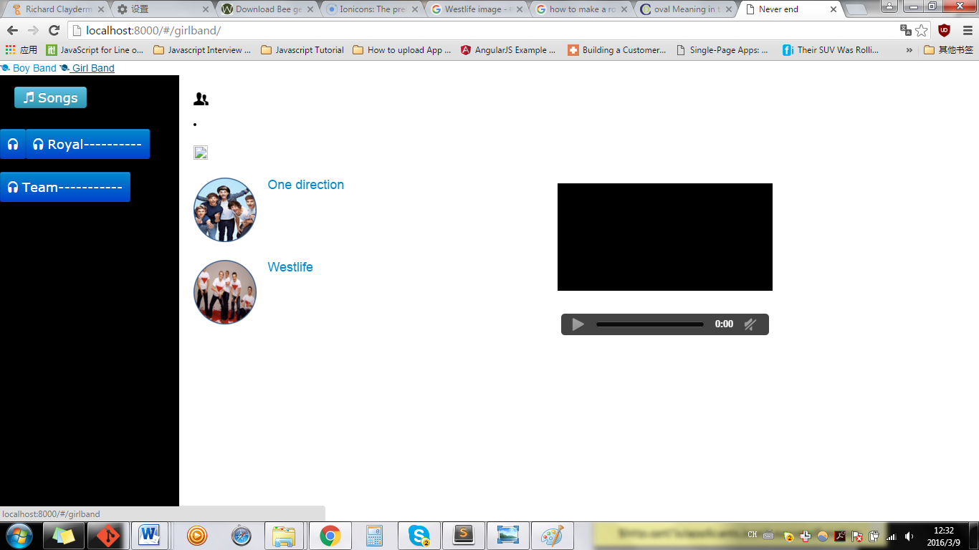

One direction is not a girlband!!!!!!!!!!!!!!!!!!

WRONG

$scope.getVideo4singer=function(video){

***$scope.selectedVideo4SingerList=getSingerService.clearVideo4Singer();***

***$scope.selectedVideo4SingerList.saveVideo4Singer(video);***

***$scope.selectedVideo4SingerList.listVideo4Singer();***

***};***

***//***********video is a parameter, can’t save by Services***

***CAUSE THE FOLLOWING:***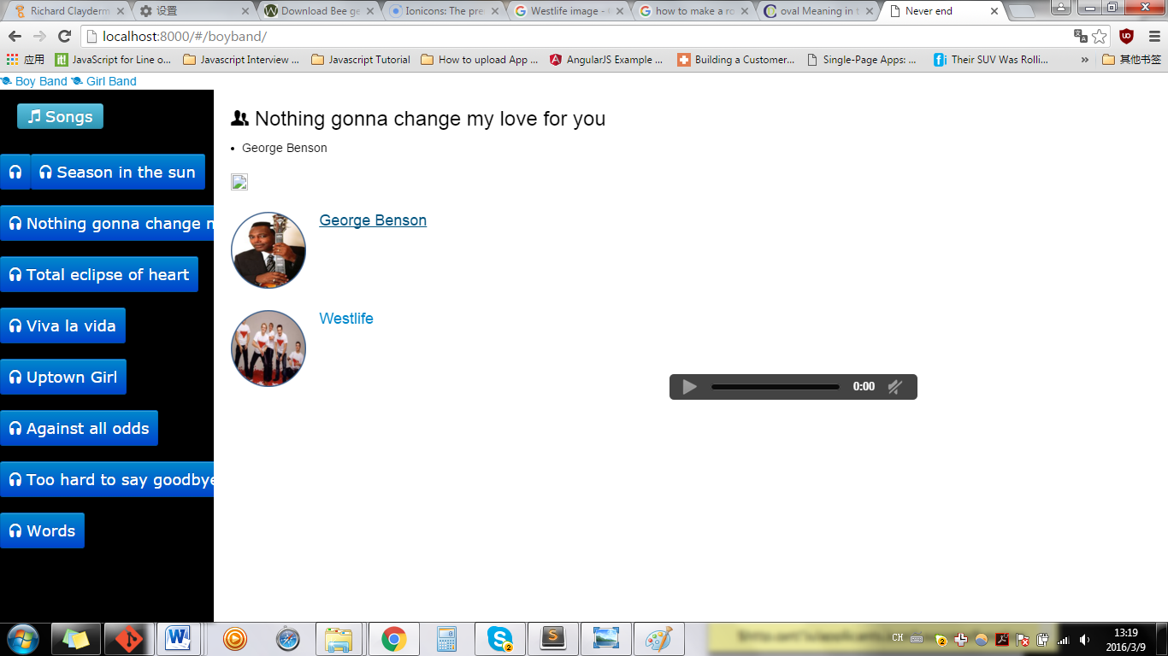

***NO VIDEO!!!!!!!!!!!!!!!!\*\*\*\*\*\*\*\*\*\*\*\*\*\*\****

***RIGHT***

***$scope.selectedVideo4SingerList=getSingerService.clearVideo4Singer();***

***angular.forEach($scope.selectedVideoList,function(s){***

***if(video.SINGERID!=""){***

***if(s.SINGERID==video.SINGERID){***

***$scope.selectedVideo4SingerList.saveVideo4Singer(s);***

***$scope.selectedVideo4SingerList.listVideo4Singer();***

***};***

***};***

***});***

**/***You can only save s----which is controllers’s object, can’t save a parameter fr.html**